# 1D agent dynamics with intermittent relative and global position measurements

## Problem statement

Each agent is assumed to have second-order dynamics, as:

$${\dot{\overset{̲}{x}}}_{i}=\left[\begin{matrix}0 & 1 \\ 0 & 0\end{matrix}\right]{\overset{̲}{x}}_{i}+\left[\begin{aligned}0 \\ 0\end{aligned}\right]u_{i}+\left[\begin{aligned}0 \\ 1\end{aligned}\right]w_{i}$$

${\overset{̲}{x}}_{i}={\left[\begin{matrix}r_{i} & {\dot{r}}_{i}\end{matrix}\right]}^{T}$ is the position and speed of agent *i* in a 1D framework. We assume velocity measurements occur at a fixed fast rate, 50 Hz, but position measurements are available intermittently, with average period $T_{G}$, for any agent. We assume relative range measurements to another agent *j* are available with average period $T_{R}$. The time between updates for intermittent measurements is modelled as a random variable having an exponential distribution.

A continuous-discrete linear Kalman filter is formulated. The penalty associated with the relative range measurement is an increase in the associated state space, which grows like $Nn(Nn+1)$ for $N$ agents with $n$ states each when the covariance is included (although this is propagating the full covariance, not taking advantage of symmetry, so the situation is somewhat less unfavorable). Two agents, each estimating the common state $\overset{̲}{X}=\left[\begin{matrix}r_{1} & \dot{r_{1}} & r_{2} & {\dot{r}}_{2}\end{matrix}\right]$ are assumed for the simplest case. The measurement model for each measurement type is as follows, where $y_{i}$ is the measurement made by agent *i*:

Velocity-level measurements:

$$y_{i}=\left[\begin{matrix}0 & δ_{1i} & 0 & δ_{2i}\end{matrix}\right]\overset{̲}{X}+v_{IMU}$$

Global position-level measurements:

$$y_{i}=\left[\begin{matrix}δ_{1i} & 0 & δ_{2i} & 0\end{matrix}\right]\overset{̲}{X}+v_{GPS}$$

Relative range measurements:

$$y_{i}=\left[\begin{matrix}1 & 0 & -1 & 0\end{matrix}\right]\overset{̲}{X}+v_{rel}$$

Using the convention $v_{k}\sim N(0,R_{k})$, we assume $R_{GPS}<R_{rel}$. At this point, there is no direct communication of the more accurate GPS-like measurement from agent to agent, and we propagate the system in the proposed form to examine the effect of each of these measurements on the associated position error variance.

It should also be noted that this formulation requires the control inputs to both vehicles be known to each vehicle, which is unrealistic given the other assumptions. Conceivably this could be addressed by sharing IMU data.

## Simulation

For simulation, the following values are used:

$$T_{G}=10 sec \\ T_{R}=1 sec \\ Q_{i}=1 ∀ i \\ σ_{imu}=.2 \\ σ_{rel}=10 \\ σ_{gps}=1 \\ {\overset{̲}{x}}_{1}\left(0\right)={\left[\begin{matrix}5 & 0\end{matrix}\right]}^{T} \\ {\overset{̲}{x}}_{2}\left(0\right)={\left[\begin{matrix}-2.4 & 0\end{matrix}\right]}^{T} \\ u_{1}=-\left(r_{1}-\cos\left(t\right)\right) \\ u_{2}=-\left(r_{2}-\sin\left(t\right)\right)$$

A simulation time of 60 seconds is used; all estimated states are initially zero with identity covariance. The following plots summarize results. It should be emphasized that each vehicle is estimating its full state and the other agent’s as well, and that the primary limitation in utilizing the relative range measurement appears to be the confidence in the other vehicle’s position.

In each figure, a square indicates a time at which the vehicle received a relative range measurement; a diamond indicates that a global position measurement was received. (For reference, these symbols are placed at y = 0 in each plot.) Three figures are shown for each vehicle; in the top one, the estimate of that vehicle’s position is shown along with the truth value (solid blue line). In the second figure, the estimate of the other vehicle’s position is shown. In the third figure, the estimate error in its own position is shown with the 3-sigma bound from the covariance matrix.

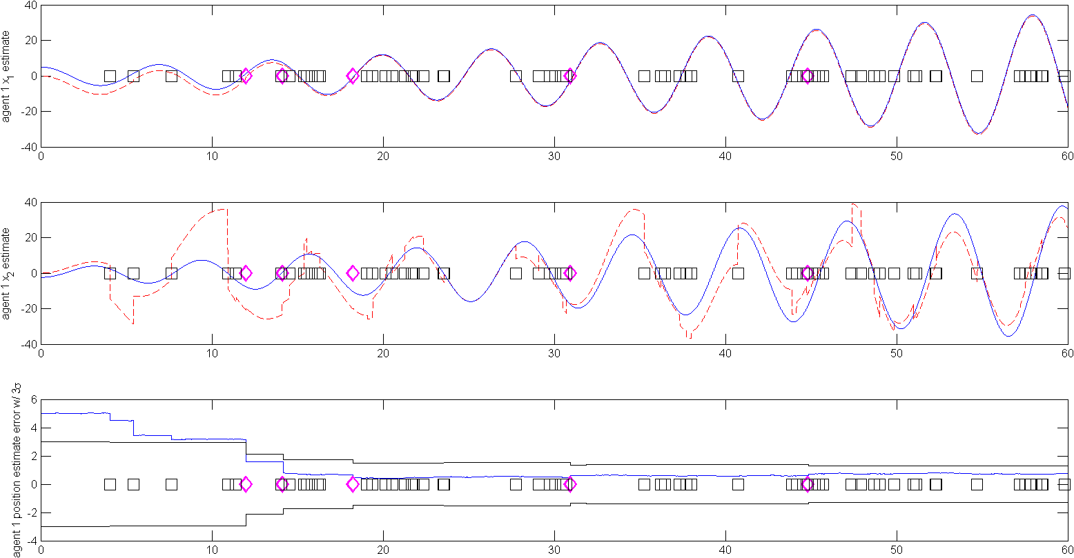

The above figure shows the position estimate histories for agent 1. Initial range measurements reduce estimate error noticeably, but the benefit of these measurements quickly diminishes after several inertial measurements are made. There appears to be a bias in the position estimate which is not eliminated by subsequent inertial position measurements.

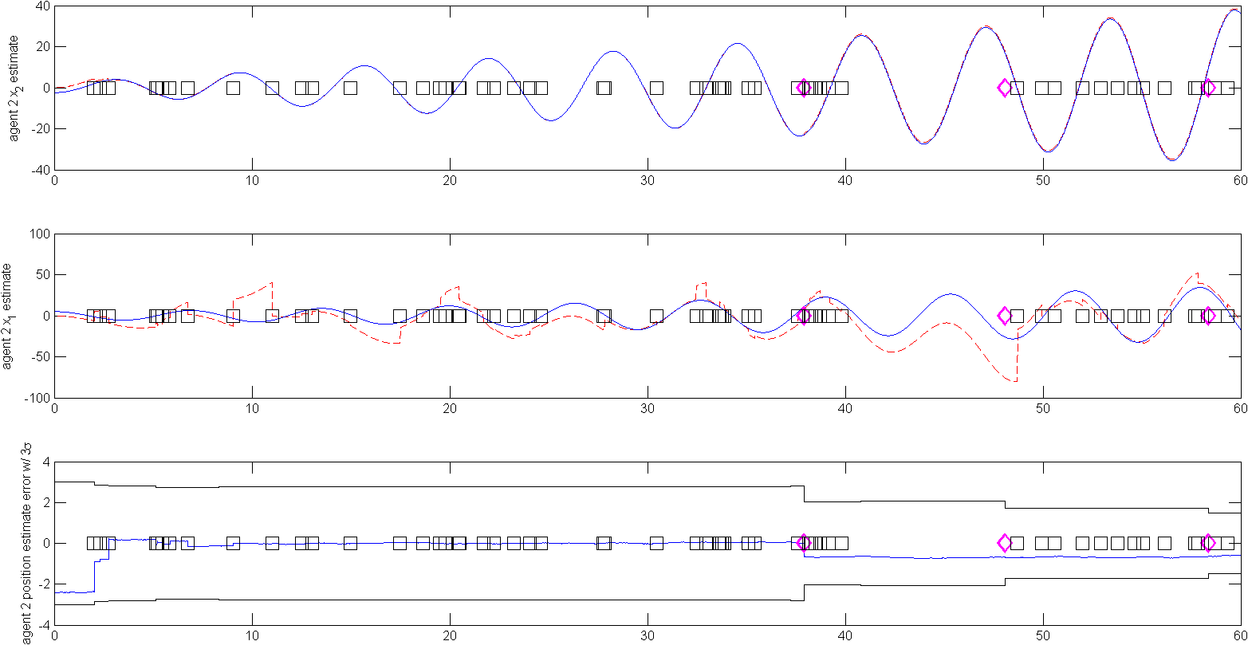

The above figure shows position estimates for agent 2. The initial position error is smaller an converges quickly. The expected variance remains high until the first GPS update around t = 38, but the error is essentially zero during this time (due to the high fidelity in the velocity-level measurements). Interestingly, the inertial position measurement at t = 38 introduces a bias in the position error that is not present previously.

## Additional thoughts

Given a relatively high-fidelity IMU, the vehicle can propagate its own position with little bias for a long period given a good initial position estimate. Propagating a model of all other agents to take advantage of relative range measurements does not seem like a sustainable model for larger coalitions, and does not take advantage of sharing measurements or computational resources. For instance, instead of a relative range measurement, agents could simply communicate measurements of each other’s positions and an associated measurement variance. However, this sort of communication should take into account the transmitting agent’s own confidence in its position, and I’m not immediately sure how to do that without maintaining some ongoing estimate of the relative position of the target agent.

Added: The following figure shows an agent history with no relative position updates, and all other values the same. There is more bias in its own position estimate, but the 3 $σ$ bounds are essentially unchanged. The estimate of the other agent’s position is biased, but no longer really being used.

(In this simulation, $u_{1}=-\left(r_{1}-\cos\left(.650124t\right)\right)$ was used to ensure the agent dynamics are excited at different frequencies.)

